Lab 1:

Q1.

* Debug
* Java (default)
* Java Browsing
* Java Type Hierarchy
* Planning
* Resource
* Team Synchronizing
* XML

Q2.

* Problems
* @Javadoc
* Declaration
* Console
* Package

Q3.

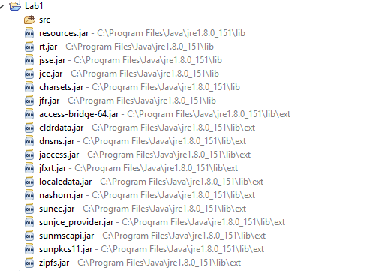

Q4.

**public** **class** BuddyInfo {

**public** **static** **void** main(String[] args) {

// **TODO** Auto-generated method stub

}

}